Module 3 Summary – Jacob booth 221530207

Response to feedback
Regarding feedback for this module, I’ve blended the concepts together so the summary reads as more of a module narrative with clear sub-modules. I’ve ditched the modular approach, emphasising concept-integration so each topic is discussed in context, with clearer key-takeaways. I’ve maintained my emphasis on inter-dependace of linked concepts to discuss each topic with respect to each other, minimising any rephrasing. This attempt focuses most on expanding the overall picture as opposed to addressing each portion on its own.
Module Learning Objectives
I certify that I achieved the following learning objectives for the module:
1) Apply the inversion algorithm to find a matrix inverse
2) Identify and work with elementary matrices
3) Work with matrices algebraically and identify correspondence between key linear mappings and their matrices
Key Definitions and Theorems
Matrix Inverses
Textbook Ref | Theorem/Definition statement | Learning Notes
Definition 2.11  Matrix Inverse | If A is a square matrix, a matrix B is called an inverse of A if and only if  AB = I and BA = I  A matrix A that has an inverse is called an invertible matrix and denoted A⁻¹ | DIFFERENT FROM THE NEGATION, remember that this isn’t the negative matrix but its inversion
Theorem 2.4.1 Uniqueness of inverse | If B and C are both inverses of A, then B = C. | Think about the rules with matrix multiplication, sometimes C might not be known but must still be identical if it returns the same result as B, there’s a single inverse for every invertible matrix
Matrix Inversion Algorithm | If A is an invertible (square) matrix, there exists a sequence of elementary row operations that carry  A to the identity matrix I of the same size, written A→I. This same series of row operations  carries I to A⁻¹; that is, I →A⁻¹. The algorithm can be summarized as follows:  [ A I ] → [ I A⁻¹]  where the row operations on A and I are carried out simultaneously. | Note that the inverse doesn’t always exist, and REMEMBER that the identity matrix is the matrix representation of scalar 1, it leaves it unchanged (replacing the 1s with any real x will be that scalar’s matrix representation, I assume)
Theorem 2.4.4 Inverse properties | All the following matrices are square matrices of the same size.  1. I is invertible and I⁻¹ = I.  2. If A is invertible, so is A⁻¹, and (A⁻¹)⁻¹ = A.  3. If A and B are invertible, so is AB, and  (AB)⁻¹ = B⁻¹A⁻¹.  4. If A₁, A₂, . . . , A_{k} are all invertible, so is their product A₁A₂ ···A_{k}, and  5. If A is invertible, so is A^{k} for any k ≥ 1, and  (A^{k})⁻¹ = (A⁻¹)^{k}.  6. If A is invertible and a  0 is a number, then aA is invertible and  7. If A is invertible, so is its transpose A^{T}, and  (A^{T} )⁻¹ = (A⁻¹)^{T}. | Note the swapping behaviour in the definition, applying inverses to the matrices inverts their corresponding multiplication order.  If multiplying by the inverse returns “1” then it might be similar to multiplying the matrix by 1/A, or dividing A/A? Multiplying by the inverse seems to be the tool for this.
Theorem 2.4.5 Inverse Theorem | The following conditions are equivalent for an n×n matrix A:  1. A is invertible.  2. The homogeneous system Ax = 0 has only the trivial solution x = 0.  3. A can be carried to the identity matrix I_{n} by elementary row operations.  4. The system Ax = b has at least one solution x for every choice of column b.  5. There exists an n×n matrix C such that AC = I_{n}. | It needs to be square, no empty vars, and the corresponding matrix that reduces it to I is the inverse. NOTE an identity matrix is essentially in RREF without the constants, it represents 1 for each x in x1, …, xn.
Elementary Matrices
Textbook Ref | Theorem/Definition statement | Notes
Definition 2.12 Elementary Matrices | An n×n matrix E is called an elementary matrix if it can be obtained from the identity matrix I_{n} by a single elementary row operation (called the operation corresponding to E). We say that E is of type I, II, or III if the operation is of that type:  - Interchanging two rows  - Multiplying one row by a non-zero number  - Adding a multiple of one row to a different row | Elementary row operations in matrix form, convenient application
Theorem 2.5.4  Uniqueness of reduced row-echelon form | If a matrix A is carried to reduced row-echelon matrices R and S by row operations, then R = S. | If you apply row operations to a matrix and get two different reduced forms, those forms must be equal, no matter how you simplify the matrix, it will return the same result.
Linear Transformations
Textbook Ref | Theorem/Definition statement | Notes
Definition 2.13 | A transformation T :   ℝ^{n} → ℝ^{m} is called a linear transformation if it satisfies the following two conditions for all vectors x and y in ℝ^{n} and all scalars a:  T1 T(x+y) = T(x)+T(y)  T2 T(ax) = aT(x) | Bare in mind the behaviour of linear transformations is essentially matrix multiplication, I’ll lean more into this idea of a T() function call passing matrix as a param, this describes how the arithmetic can be reordered.
Theorem 2.6.1 Linearity Theorem | If T :   ℝ^{n} → ℝ^{m} is a linear transformation, then for each k = 1, 2, . . .  T(a₁x₁+a₂x₂+···+a_{k}x_{k}) =a₁T(x₁)+a₂T(x₂)+···+a_{k}T(x_{k})  for all scalars a_{i} and all vectors x_{i} in ℝ^{n}. | The effects of multiplying with linearity, scalar multiplication can be applied after a transformation and resolve the same.  NOTE continue to actively recognise individual vectors which make up the matrix
Theorem 2.6.4 Rotations | The rotation R : ℝ² → ℝ² is the linear transformation with matrix | Think about rotation tools in graphic design software, special matrices like this make vector graphics easily editable
Theorem 2.6.5 Reflections | Let Q_{m} denote a reflection transformation with respect to the line y = mx. Then Q_{m} : ℝ² → ℝ² is a linear transformation with matrix | Another graphic design concept, this allows us to easily create mirrored duplicates along an axis/plane
Theorem 2.6.6 Projection | Let P_{m} be projection on the line y = mx. Then P_{m} : ℝ² → ℝ² is a linear transformation with matrix | This lies at the core of pre-ray-traced graphics and screen-space rendering, determining how 3D objects should appear on a 2D screen from different angles

Module 3
Module 3 builds on matrix multiplication and RREF reduction to introduce a sequential method for inverting a matrix. This module unpacks the concepts necessary for transforming a system linearly through elementary operations, and how elementary matrix products can be used to express reduction/transformation sequences. These are demonstrated with respect to inverse theorem and linear theorem for maintaining system consistency.
3.1 Matrix Inverses
Some matrices can be inverted, causing them to induce the inverse-effect of the original matrix transformation. Not all matrices have inverses. If a matrix transformation induces a change, then per Definition 2.11, the inverse of that matrix undoes that change. All matrix inverses are unique according to Theorem 2.4.1. Theorem 2.4.5 outlines the 5 conditions of n*n matrices according to inverse theorem. As a baseline, condition 1 infers that all n*n matrices are invertible. Conditions 4 - 5 express further characteristics of invertible matrices, which the matrix inversion algorithm operates under. The algorithm leverages linearity and inverse theorem for a step-by-step approach to finding the inverse.
Summarise the matrix inversion algorithm in word, referring to an example in your evidence or self-assessment
Beginning with the augmented [ A | I ] matrix, row operations are applied such that the left side is converted into I, its corresponding identity. The right side will naturally be brought to A⁻¹. If the LHS cannot be reduced to I, the matrix has no inverse, and the algorithm fails. This works within the conditions outlined by inverse theorem and characteristics of inverse properties for sequential, consistent inversion. The following example demonstrates this with a combination of scalar-mult and scalar-row-add operations. The LHS reduces to RREF as the RHS is carried to A⁻¹.
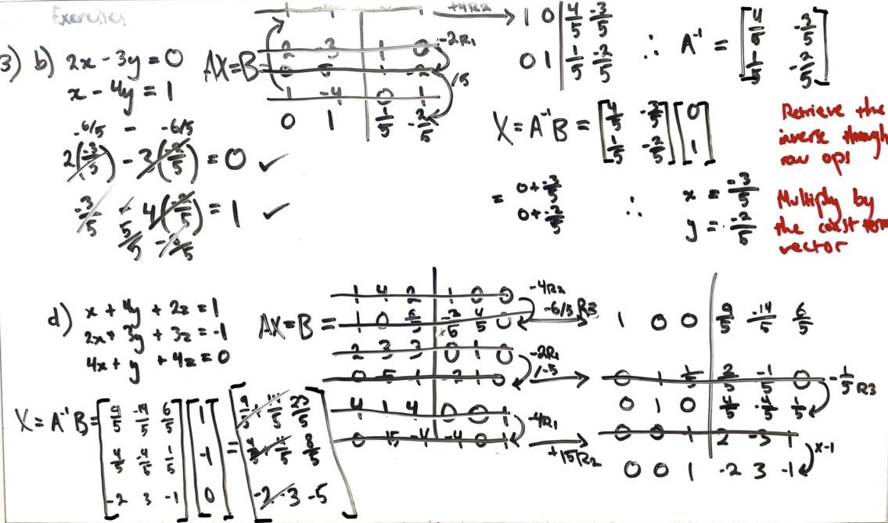

If the rank of an n*n matrix is less than n, what does this tell us about the inverse matrix?
Theorem 2.4.5 clarifies that a matrix with rank less than n variables cannot be inverted, since the system Ax = b must have at least one x for each in column b. The algorithm will fail, with a column of only 0s, violating inverse theorem.
Provide reasoning as to whether or not a non-square matrix could have an inverse.
Non-square matrices cannot be inverted. Definition 2.11 requires A to be square for AA⁻¹ = I to be consistent. Multiplying a non-square matrix by another cannot yield an I of compatible dimensions.
3.2 Elementary Matrices
Elementary matrices represent single elementary row operations applied to the corresponding identity matrix. They’re used by the inverse algorithm during reduction, and can be composed to represent the series of operations applied to a reduced matrix. Theorem 2.5.4 reinforces that any sequence of row operations leads to a unique RREF form, but all are equal, consistent with linear transformations. Elementary matrices are always invertible, since each operation can be reversed, tying directly to the behaviour outlined in Theorem 2.4.4 (4, if A₁, A₂, . . . , A_{k} are all invertible, so is their product).
3.3 Linear Transformations
Definition 2.13 shows how linear transformations serve as mapping between vector spaces, preserving addition and multiplication linearity. The linearity of a transformation is determined by linearity theorem. Each linear transformation can be represented by a matrix, with unique matrices inducing specific effects like rotations, reflections, and projections. This is possible because linear transformations distribute over vector sums and scalar multiples.
Rotations and projections are both consistent with inverse properties and inverse theorem. Since rotations and reflections preserve the matrix rank, they’re invertible. Projections directly reduce the matrix dimensions, and by Theorem 2.4.5, cannot be inverted, due to rank-deficiency with regards to n.
What are some strategies for identifying the transformation applied in N3.4.2?
The type of transformation can be verified by checking whether the e₁₁ and e₂₂ values are equal, indicating a rotation. If instead, the e₁₂ and e₂₁ elements are equal, it’s likely a reflection. These characteristics are demonstrated by the following example, which draws on Theorem 2.6.4 and Theorem 2.6.5 to clarify the identification.

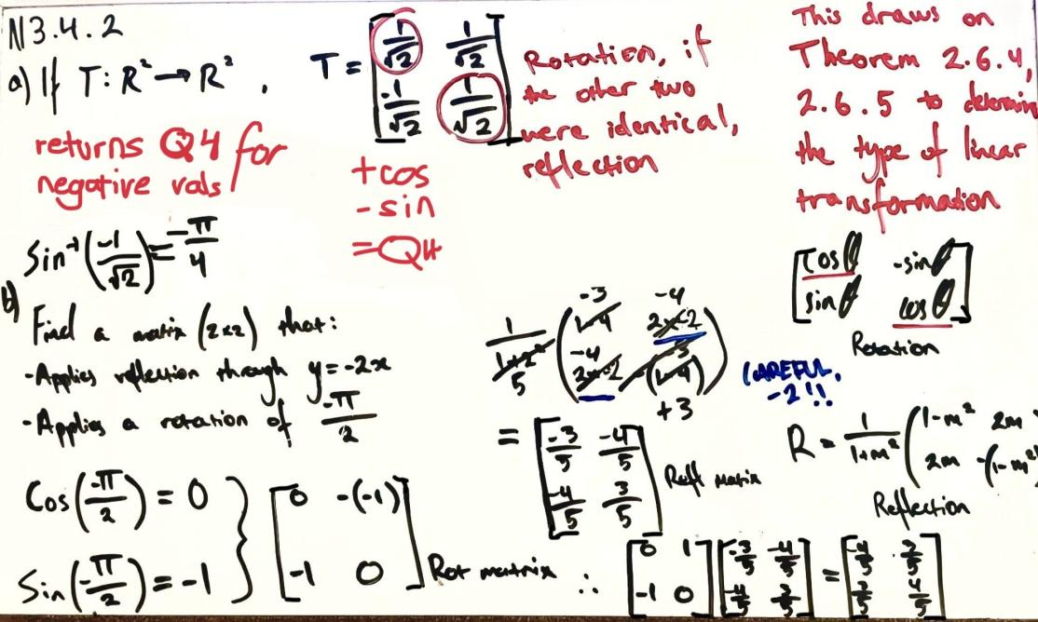
Module 3 defines all the building blocks for expressing complex transformations as a composition of elementary linear operations. Inverse properties provide constraints for invertible matrices Inverse matrices reverse the order of operations, and by extension, the effects induced by the original transformation. This scopes row ops within elementary matrices, and their sequence within composition. Multiplying compositions yields more complex transformations, constructed of all the same elementary parts in the same hierarchy. Summarily, if a linear system is subject to linear transformation from another matrix, it’s only possible to retrieve the original system if the matrix can be inverted, reversing the elementary operations the transformation is composed of.

Reflecting on the content:
This module was a good point for tying together Modules 1, 2, and composition/transformations. I had a few problems getting my calculator configured for working in fractions for the trigonometry aspects, but the most important concepts were very intuitive to work with. I had to work with some rephrasing to really get my head around the composition annotations, but I feel more confident now that I’ve got 3 clear stages of progression. The hierarchy established in this module will help me scope the upcoming modules with better context now that these core building blocks are established. Overall, a very important module for using all module 1 and 2 concepts in context.

References
Summary and Notes
[1] D. Margalit and J. Rabinoff, “Matrix Transformations,” Interactive Linear Algebra, LibreTexts, [Online]. Available: https://math.libretexts.org/Bookshelves/Linear_Algebra/Interactive_Linear_Algebra_(Margalit_and_Rabinoff)/03%3A_Linear_Transformations_and_Matrix_Algebra/3.01%3A_Matrix_Transformations.
[Accessed: Jul. 30, 2025].
[2] D. Margalit and J. Rabinoff, “Matrix Inverses,” Interactive Linear Algebra, LibreTexts, [Online].
Available: https://math.libretexts.org/Bookshelves/Linear_Algebra/Interactive_Linear_Algebra_(Margalit_and_Rabinoff)/03%3A_Linear_Transformations_and_Matrix_Algebra/3.05%3A_Matrix_Inverses.
[Accessed: Jul. 30, 2025].
[3] A. Doerr and K. Levasseur, “Matrix Inversion,” Applied Discrete Structures, LibreTexts, [Online].
Available: https://math.libretexts.org/Bookshelves/Combinatorics_and_Discrete_Mathematics/Applied_Discrete_Structures_(Doerr_and_Levasseur)/12%3A_More_Matrix_Algebra/12.02%3A_Matrix_Inversion.
[Accessed: Jul. 30, 2025].
Calculations/Verification
[4] Apple Inc., “Calculator Infinity,” App Store. [Online].
Available: https://apps.apple.com/us/app/calculator/id458535809.

